**CLINIC MANAGEMENT SYSTEM**

**SRI DHARMASTHALA MANJUNATHESHWARA COLLEGE (AUTONOMOUS)**

**UJIRE – 574240**

**Department of Computer Science**



**Certificate for the approval of project report**

This is to certify that following students of 3rd BSc have satisfactorily completed the project **“CLINIC MANAGEMENT SYSTEM”** for the BSc Computer Application degree prescribed by the college during the academic year 2022-2023.

**Team members,**

Smitha K, 200222

Anvitha D, 200224

Ramyaganga, 200227

Mr. Shailesh Kumar Ms. DivyaYadav Dr. B.A. Kumar Hegde

**Head of the Department Project Guide Principal**

Examiners:

**DECLARATION**

**DECLARATION**

We hereby declare that this project work entitles “**CLINIC MANAGEMENT SYSTEM**” has been prepared by us during the year 2022- 2023 under the guidance of Mrs. DivyaYadav, Department of Computer Science, SDM College in the partial fulfillment of BSc degree prescribed by the college.

We also declare that this project is the outcome of our own effort, that it has not been submitted by any other university for the award of any degree.

**Team Members:**

|  |  |  |
| --- | --- | --- |
| **Name** | **Roll No.** | **Signature** |
| Smitha K | 200222 |  |
| Anvitha D | 200224 |  |
| Ramyaganga | 200227 |  |

**ACKNOWLEDGEMENT**

**ACKNOWLEDGEMENT**

We would like to thank our Principal Dr. B.A. Kumar Hegde, for his support. We also thank Mr. Shailesh Kumar, HOD, Department of Computer Science, SDM College Ujire, for his valuable suggestions.

We would like to thank Mrs. DivyaYadav, Department of Computer Science, SDM College Ujire, for her help and for providing guidance in developing the project.

**Team Members:**

|  |  |  |
| --- | --- | --- |
| **Name** | **Roll No.** | **Signature** |
| Smitha K | 200222 |  |
| Anvitha D | 200224 |  |
| Ramyaganga | 200227 |  |

**INDEX**

|  |  |  |
| --- | --- | --- |
| **SL. NO.** | **CONTENT** | **PAGE NO.** |
| **1.** | **Synopsis** |  |
| **2.** | **Module description** |  |
| **3.** | **Database tables** |  |
| **4.** | **Description about the software** |  |
| **5.** | **User interface** |  |
| **6.** | **Source code** |  |
| **7.** | **System requirement** |  |
| **8.** | **Conclusion** |  |
| **9.** | **Bibliography** |  |

**SYNOPSIS**

**Project Title: “Clinic Management System”**

**Description:** The main objective of the Clinic Management System is to manage the details of clinic, doctor, patients, medicine and appointment for consultation. The purpose of the project is to build an application program to reduce the manual work for managing the clinic, doctor and medicine. Also, it tracks all the details about the patients. Provides the searching facilities based on various factors and assists the staff in capturing the efforts spent on their respective working areas. The transactions and consultations are executed offline and only the appointments are considered in online mode. It generates the reports on medicines. This project helps to integrate all the details about the patients.

**Languages Used:**

Front End: VB.Net

Back End: MS Access

**Team Members:**

|  |  |  |
| --- | --- | --- |
| **Name** | **Roll No.** | **Signature** |
| Smitha K | 200222 |  |
| Anvitha D | 200224 |  |
| Ramyaganga | 200227 |  |

**DESCRIPTION ABOUT THE SOFTWARE**

**INTRODUCTION TO VISUAL BASIC**

**Introduction to VB.NET:**

Visual Basic .Net (VB.NET) is an object-oriented computer programming language implemented on the .NET framework. Although it is an evolution of classic Visual basic language, it is not backwards-compatible with VB6 and any code written in the old version does not compile under VB.NET.

Like all other .NET languages, VB.NET has complete support for object-oriented concepts. Everything in VB.NET is an object, including all the primitive types and user defined types, events and assemblies. All objects inherit from the base class object.

VB.NET is implemented by Microsoft’s .NET Framework. Therefore, it has full access to all the libraries in the .NET framework. It is also possible to run VB.NET, not only under Windows, but even under Linux or MacOS.

**Visual Basic 6.0 available on three conditions:**

1. **Standard edition:** It is under to write application to Windows 95 and Windows XP.it is used in 64- bit version. Standard edition contains Standard Controls (list, checkbox, and so on). It includes the VB development environment, setup kits, icon files and sample applications.
2. **Professional edition:** This is used by the Professional programmers. It includes all the features of standard edition plus addition custom controls, crystal reports book online help, Microsoft Windows help, editor, resource compiler, DAO and other tool help, Microsoft Server, Sybase an Oracle.
3. **Enterprise edition:** It is used to build client- server Applications; It includes all features of professional editor plus source code control, remote OLE automation, remote database access tools, component manager and data explorer.

**INTRODUCTION TO MS-ACCESS**

**Introduction to MS-Access:**

Microsoft Access is a database Management system (DBMS) from Microsoft combines the relational Microsoft jet Database Engine with a graphical user interface and Software-Development tools. It is a member of Microsoft office suite of application, included in the professional and higher editions or sold separately. Microsoft Access stores data in its own format based on the access Jet Database Engine. It can also Link or import directly to data stored in other application and databases.

Software development, data architects and power users can use Microsoft Access to develop application software. Like other Microsoft office Application, access is supported by visual basic for applications (VBA); an object-oriented programming language that can refer a variety of objects including DAO, ActiveX Data objects, and many other ActiveX Components, Visual Objects used in forms and report expose their methods any properties in the VBA programming environment and VBA code modules may declare or call windows operating system operations.

**MODULE DESCRIPTION**

**About The Project:**

The Project “Clinic Management System” is a software for making appointments in online mode and inserting, updating, deleting the medicine stocks and personal information details are stored in the database. This software reduces the manual work that is involved in day to day in clinic.

**Login:** In this module, there are 2 users, Doctor and patient who can login into the project by entering correct username and password.

**Appointment:** In this module, Patient can select a date for visiting clinic for various fixed reasons.

**Medicines:** User can insert, update, search, delete and view the stock details of medicine when it is required

**Accessories:** Doctor user can insert, update, search, delete and view the stock details of medicine when it is required and also view the appointment list to make a schedule as per doctor’s schedule history.

**DATABASE TABLES**

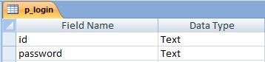

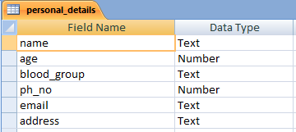

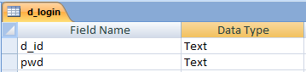

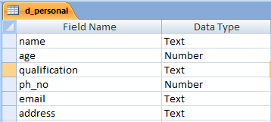

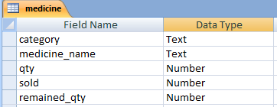

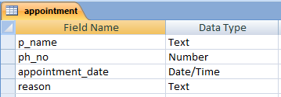

**USER INTERFACE**

**LOGIN:**

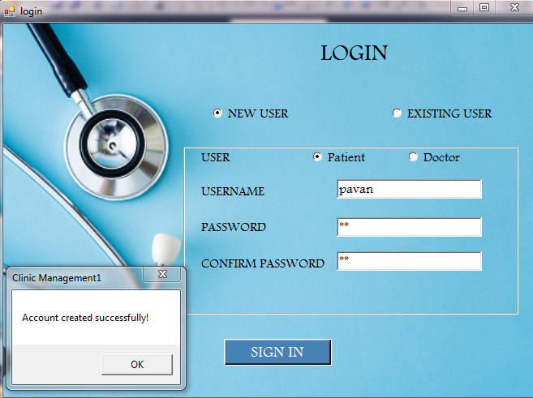

**PERSONALDETAILS (PATIENT’S VIEW):**

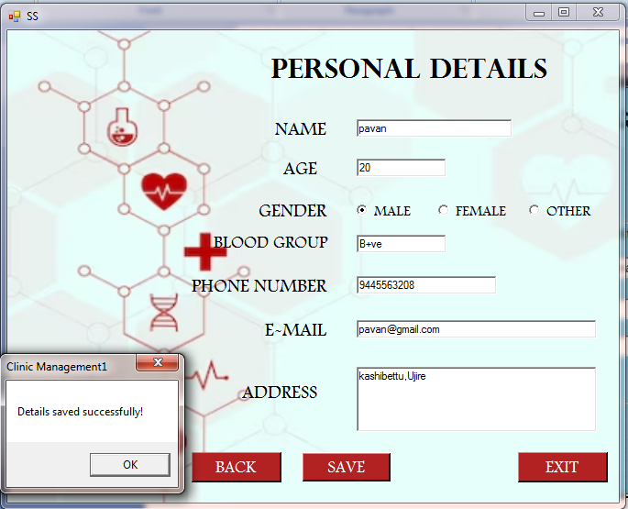

**HOMEPAGE (PATIENT’S VIEW):**



**APPOINTMENTBOOKING:**

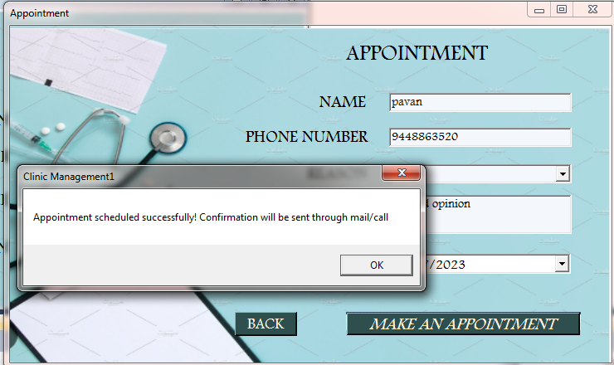

**ACCOUNT DETAILS PROFILE(PATIENT’S VIEW):**

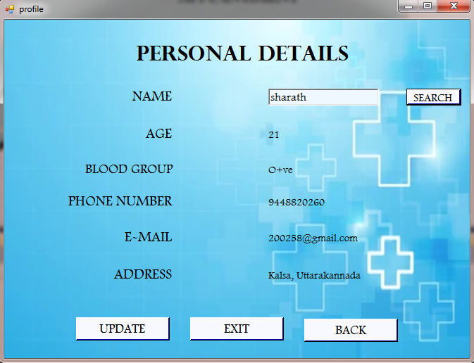

**PERSONAL DETAILS (PATIENT’S VIEW):**

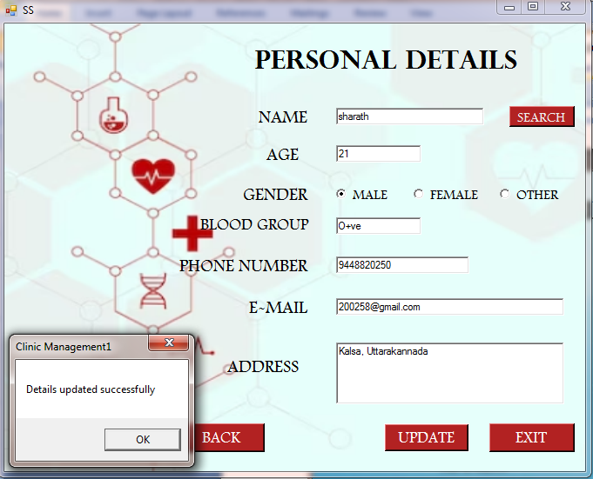

**HOMEPAGE (DOCTOR’S VIEW):**

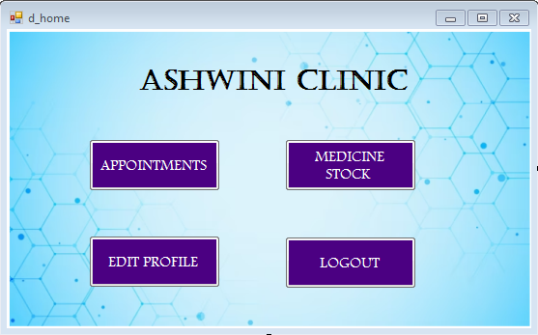

**APPOINTMENT VIEW:**

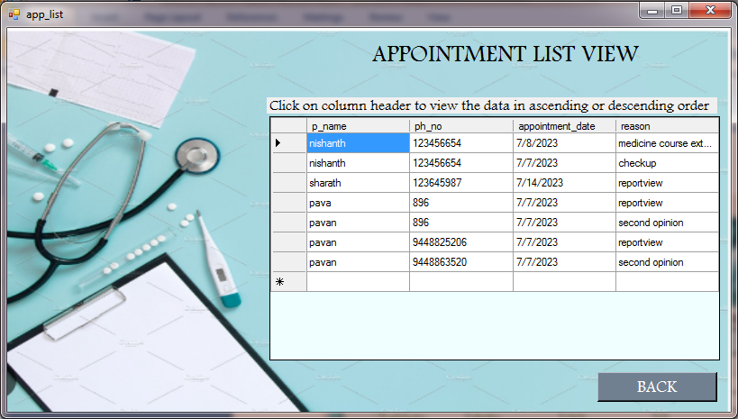

**MEDICINE STOCK DETAILS:**

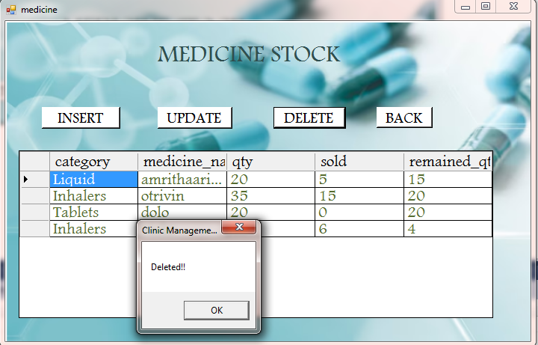

**MEDICINE INSERT:**

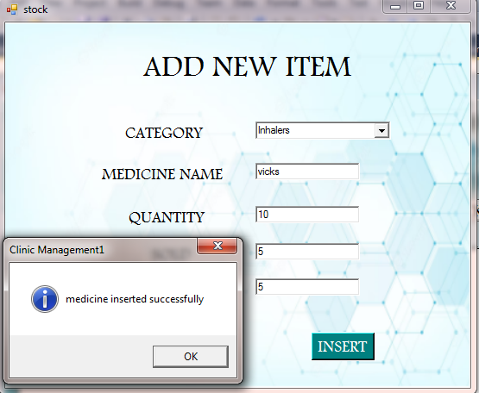

**MEDICINE UPDATE:**

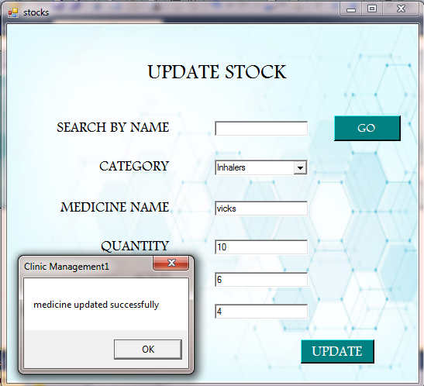

**SOURCE CODE**

**LOGIN:**

Imports System.Data.OleDb

Public Class login

Dim s1, s2 As String

Dim cnn As OleDb.OleDbConnection

Dim cmd As OleDb.OleDbCommand

Dim drAsOleDb.OleDbDataReader

Private Sub login_Load(ByVal sender As System.Object, ByVal e As System.EventArgs) Handles MyBase.Load

cnn = New OleDb.OleDbConnection("Provider=Microsoft.ACE.OLEDB.12.0;Data Source=E:\clinic mgt project\patient_db.accdb")

cnn.Open()

RadioButton1.Visible = True

RadioButton2.Visible = True

GroupBox1.Visible = False

End Sub

Private Sub RadioButton2_CheckedChanged(ByVal sender As System.Object, ByVal e As System.EventArgs) Handles RadioButton2.CheckedChanged

GroupBox1.Visible = True

Label2.Visible = True

Label3.Visible = True

Label4.Visible = True

Label5.Visible = False

TextBox1.Visible = True

TextBox2.Visible = True

TextBox3.Visible = False

sign_in.Visible = False

log_in.Visible = True

RadioButton3.Visible = True

RadioButton4.Visible = True

End Sub

Private Sub RadioButton1_CheckedChanged(ByVal sender As System.Object, ByVal e As System.EventArgs) Handles RadioButton1.CheckedChanged

GroupBox1.Visible = True

Label2.Visible = True

Label3.Visible = True

Label4.Visible = True

Label5.Visible = True

TextBox1.Visible = True

TextBox2.Visible = True

TextBox3.Visible = True

sign_in.Visible = True

log_in.Visible = False

RadioButton3.Visible = True

RadioButton4.Visible = True

End Sub

Private Sub log_in_Click(ByVal sender As System.Object, ByVal e As System.EventArgs) Handles log_in.Click

Dim drAsOleDb.OleDbDataReader

If Len(TextBox1.Text) = 0 Then

MsgBox("fill all fields ")

ElseIfLen(TextBox2.Text) = 0 Then

MsgBox("fill all fields ")

ElseIf (RadioButton3.Checked Or RadioButton4.Checked) = False Then

MsgBox("fill all fields ")

End If

If RadioButton3.Checked = True Then

Dim flag As Boolean = False

s1 = "select * from p_login "

cmd = New OleDb.OleDbCommand(s1, cnn)

dr = cmd.ExecuteReader()

While (dr.Read())

If (TextBox1.Text = Trim(dr(0))) And (TextBox2.Text = Trim(dr(1))) Then

flag = True

Exit While

Else

flag = False

End If

End While

If flag = False Then

MsgBox("wrong username or password")

TextBox1.Clear()

TextBox2.Clear()

TextBox1.Focus()

flag = True

Else

homepage.Show()

Me.Hide()

End If

ElseIf RadioButton4.Checked = True Then

Dim flag As Boolean = False

s1 = "select * from d_login "

cmd = New OleDb.OleDbCommand(s1, cnn)

dr = cmd.ExecuteReader()

While (dr.Read())

If (TextBox1.Text = Trim(dr(0))) And (TextBox2.Text = Trim(dr(1))) Then

flag = True

Exit While

Else

flag = False

End If

End While

If flag = False Then

MsgBox("wrong username or password")

TextBox1.Clear()

TextBox2.Clear()

TextBox1.Focus()

flag = True

Else

d_home.Show()

Me.Hide()

End If

End If

End Sub

Private Sub sign_in_Click(ByVal sender As System.Object, ByVal e As System.EventArgs) Handles sign_in.Click

Dim flag As Boolean = False

If Len(TextBox1.Text) = 0 Then

MsgBox("fill all fields ")

ElseIfLen(TextBox2.Text) = 0 Then

MsgBox("fill all fields ")

ElseIfLen(TextBox3.Text) = 0 Then

MsgBox("fill all fields ")

ElseIf (RadioButton3.Checked Or RadioButton4.Checked) = False Then

MsgBox("fill all fields ")

End If

If RadioButton3.Checked = True Then

s2 = "insert into p_loginvalues('" & TextBox1.Text & "','" & TextBox2.Text & "')"

ElseIf RadioButton4.Checked = True Then

s2 = "insert into d_loginvalues('" & TextBox1.Text & "','" & TextBox2.Text & "')"

End If

If RadioButton3.Checked = True Then

s1 = "select * from p_login "

ElseIf RadioButton4.Checked = True Then

s1 = "select * from d_login "

End If

If TextBox2.Text = TextBox3.Text Then

cmd = New OleDb.OleDbCommand(s1, cnn)

dr = cmd.ExecuteReader()

While (dr.Read())

If (TextBox1.Text = Trim(dr(0))) Or (TextBox2.Text = Trim(dr(1))) Then

MsgBox("Already taken!")

flag = True

MsgBox("Re-enter id and password")

Exit While

Else

flag = False

End If

End While

Else

MsgBox("Password mismatched")

TextBox1.Clear()

TextBox2.Clear()

TextBox3.Clear()

TextBox1.Focus()

RadioButton3.Checked = False

RadioButton4.Checked = False

flag = True

End If

If RadioButton3.Checked Then

If flag = False Then

cmd = New OleDb.OleDbCommand(s2)

cmd.Connection = cnn

cmd.ExecuteNonQuery()

MsgBox("Account created successfully!")

personal.Show()

Me.Hide()

TextBox1.Clear()

TextBox2.Clear()

TextBox3.Clear()

TextBox1.Focus()

RadioButton3.Checked = False

RadioButton4.Checked = False

End If

TextBox1.Clear()

TextBox2.Clear()

TextBox3.Clear()

RadioButton3.Checked = False

RadioButton4.Checked = False

ElseIf RadioButton4.Checked Then

If flag = False Then

cmd = New OleDb.OleDbCommand(s2)

cmd.Connection = cnn

cmd.ExecuteNonQuery()

MsgBox("Account created successfully!")

d_personal.Show()

Me.Hide()

TextBox1.Clear()

TextBox2.Clear()

TextBox3.Clear()

TextBox1.Focus()

RadioButton3.Checked = False

RadioButton4.Checked = False

End If

TextBox1.Clear()

TextBox2.Clear()

TextBox3.Clear()

RadioButton3.Checked = False

RadioButton4.Checked = False

End If

If RadioButton3.Checked = True Then

personal.Show()

ElseIf RadioButton4.Checked = True Then

d_home.Show()

End If

End Sub

End Class

**PERSONALDETAILS (PATIENT’S VIEW):**

Imports System.Data.OleDb

Public Class personal

Dim cnn As OleDb.OleDbConnection

Dim cnn1 As OleDb.OleDbConnection

Dim cmd As OleDb.OleDbCommand

Dim drAsOleDbDataReader

Dim s1, s2, s3 As String

Private Sub person_details_Load(ByVal sender As System.Object, ByVal e As System.EventArgs) Handles MyBase.Load

cnn = New OleDb.OleDbConnection("Provider=Microsoft.ACE.OLEDB.12.0;Data Source=E:\clinic mgt project\patient_db.accdb")

cnn.Open()

update.Visible = False

Button1.Visible = False

End Sub

Private Sub btnsave_Click(ByVal sender As System.Object, ByVal e As System.EventArgs) Handles btnsave.Click

s1 = "insert into personal_details(name,age,blood_group,ph_no,email,address) values( '" &pname.Text& "'," &age.Text& ",'" &bg.Text& "'," &phno.Text& ",'" &email.Text& "','" &address.Text& "')"

s2 = "select * from personal_details"

If Len(pname.Text) = 0 Then

MsgBox("fill all fields")

ElseIfLen(age.Text) = 0 Then

MsgBox("fill all fields")

ElseIfLen(bg.Text) = 0 Then

MsgBox("fill all fields")

ElseIfLen(phno.Text) = 0 Then

MsgBox("fill all fields")

ElseIfLen(email.Text) = 0 Then

MsgBox("fill all fields")

ElseIfLen(address.Text) = 0 Then

MsgBox("fill all fields")

End If

cmd = New OleDb.OleDbCommand(s1)

cmd.Connection = cnn

cmd.ExecuteNonQuery()

MsgBox("Details saved successfully!")

homepage.Show()

Me.Hide()

pname.Clear()

bg.Clear()

phno.Clear()

email.Clear()

address.Clear()

RadioButton1.Checked = False

RadioButton2.Checked = False

RadioButton3.Checked = False

End Sub

Private Sub btnexit_Click(ByVal sender As System.Object, ByVal e As System.EventArgs) Handles btnexit.Click

End

End Sub

Private Sub update_Click(ByVal sender As System.Object, ByVal e As System.EventArgs) Handles update.Click

cmd = New OleDb.OleDbCommand

cnn1 = New OleDb.OleDbConnection

cnn1.ConnectionString = "Provider=Microsoft.ACE.OLEDB.12.0;Data Source=E:\clinic mgt project\patient_db.accdb"

cnn1.Open()

s3 = "UPDATE personal_details SET age=" &age.Text& ",ph_no=" &phno.Text&",email='" &email.Text& "',address='" &address.Text&"' where name='"

&pname.Text&"'"

cmd = New OleDb.OleDbCommand(s3, cnn)

cmd.ExecuteNonQuery()

MsgBox("Details updated successfully")

pname.Clear()

age.Clear()

phno.Clear()

email.Clear()

address.Clear()

bg.Clear()

RadioButton1.Checked = False

RadioButton2.Checked = False

RadioButton3.Checked = False

End Sub

Private Sub Button1_Click(ByVal sender As System.Object, ByVal e As System.EventArgs) Handles Button1.Click

Dim drAsOleDbDataReader

If (pname.Text = "") Then

MessageBox.Show("Please enter your name")

Else

s2 = "SELECT * FROM personal_details WHERE name='" &pname.Text& "' "

cmd = New OleDb.OleDbCommand(s2, cnn)

dr = cmd.ExecuteReader

If dr.Read Then

age.Text = dr.GetValue(1)

bg.Text = dr.GetValue(2)

phno.Text = dr.GetValue(3)

email.Text = dr.GetValue(4)

address.Text = dr.GetValue(5)

Else

MsgBox("No record found")

End If

End If

End Sub

Private Sub Button3_Click(ByVal sender As System.Object, ByVal e As System.EventArgs) Handles Button3.Click

Me.Hide()

homepage.Show()

End Sub

End Class

**HOMEPAGE (PATIENT’S VIEW):**

Public Class homepage

Private Sub appoint_Click(ByVal sender As System.Object, ByVal e As System.EventArgs) Handles appoint.Click

Me.Hide()

Appointment.Show()

End Sub

Private Sub Button2_Click(ByVal sender As System.Object, ByVal e As System.EventArgs) Handles Button2.Click

Me.Hide()

login.Show()

login.RadioButton1.Checked = False

login.RadioButton2.Checked = False

login.RadioButton3.Checked = False

login.RadioButton4.Checked = False

login.TextBox1.Clear()

login.TextBox2.Clear()

login.TextBox3.Clear()

End Sub

Private Sub Button1_Click(ByVal sender As System.Object, ByVal e As System.EventArgs) Handles Button1.Click

Me.Hide()

profile.Show()

MsgBox("Enter your name and click on search button to retrieve your details")

End Sub

Private Sub homepage_Load(ByVal sender As System.Object, ByVal e As System.EventArgs) Handles MyBase.Load

End Sub

End Class

**APPOINTMENT BOOKING:**

Imports System.Data.OleDb

Public Class Appointment

Dim cnn As OleDb.OleDbConnection

Dim da As OleDbDataAdapter

Dim dt As DataTable

Dim s1 As String

Dim cmd As OleDb.OleDbCommand

Private Sub Appointment_Load(ByVal sender As System.Object, ByVal e As System.EventArgs) Handles MyBase.Load

cnn = New OleDb.OleDbConnection("Provider=Microsoft.ACE.OLEDB.12.0;Data Source=E:\clinic mgt project\patient_db.accdb")

cnn.Open()

TextBox1.Visible = False

Label7.Visible = False

End Sub

Private Sub Button1_Click(ByVal sender As System.Object, ByVal e As System.EventArgs) Handles Button1.Click

Try

If reason.SelectedItem = "others" Then

s1 = "insert into appointment values('" &patientname.Text& "'," &phone.Text& ",'" &dtp.Value.Date& "','" & TextBox1.Text & "')"

Else

s1 = "insert into appointment values('" &patientname.Text& "'," &phone.Text& ",'" &dtp.Value.Date& "','" &reason.SelectedItem& "')"

End If

cmd = New OleDb.OleDbCommand(s1, cnn)

cmd.ExecuteNonQuery()

MsgBox("Appointment scheduled successfully! Confirmation will be sent through mail/call")

Me.Hide()

homepage.Show()

Catch ex As Exception

MsgBox("Appointment scheduled error " + ex.Message)

End Try

End Sub

Private Sub dtp_ValueChanged(ByVal sender As System.Object, ByVal e As System.EventArgs)

Dim seldate As DateTime = dtp.Value

If seldate<DateTime.Now Then

MsgBox("Invalid date", MessageBoxButtons.OK)

dtp.Value = DateTime.Now

End If

End Sub

Private Sub reason_SelectedIndexChanged(ByVal sender As System.Object, ByVal e As System.EventArgs) Handles reason.SelectedIndexChanged

If reason.SelectedItem = "others" Then

TextBox1.Visible = True

Label7.Visible = True

End If

End Sub

Private Sub Button2_Click(ByVal sender As System.Object, ByVal e As System.EventArgs) Handles Button2.Click

Me.Close()

homepage.Show()

End Sub

End Class

**ACCOUNTDETAILS PROFILE:**

Imports System.Data.OleDb

Public Class profile

Dim cnn As OleDb.OleDbConnection

Dim cmd As OleDb.OleDbCommand

Dim s2 As String

Private Sub Button1_Click(ByVal sender As System.Object, ByVal e As System.EventArgs) Handles Button1.Click

Me.Hide()

homepage.Show()

End Sub

Private Sub profile_Load(ByVal sender As System.Object, ByVal e As System.EventArgs) Handles MyBase.Load

cnn = New OleDb.OleDbConnection("Provider=Microsoft.ACE.OLEDB.12.0;Data Source=E:\clinic mgt project\patient_db.accdb")

cnn.Open()

update.Visible = True

End Sub

Private Sub btnexit_Click(ByVal sender As System.Object, ByVal e As System.EventArgs) Handles btnexit.Click

End

End Sub

Private Sub update_Click(ByVal sender As System.Object, ByVal e As System.EventArgs) Handles update.Click

personal.Show()

Me.Hide()

MsgBox("Enter your name and click on search button to retrieve your details")

personal.btnsave.Visible = False

personal.update.Visible = True

personal.btnsave.Visible = False

personal.Button1.Visible = True

End Sub

Private Sub Button2_Click(ByVal sender As System.Object, ByVal e As System.EventArgs) Handles Button2.Click

Dim drAsOleDbDataReader

If (TextBox1.Text = "") Then

MessageBox.Show("Please enter your name")

Else

s2 = "SELECT * FROM personal_details WHERE name='" & TextBox1.Text & "' "

cmd = New OleDb.OleDbCommand(s2, cnn)

dr = cmd.ExecuteReader

If dr.Read Then

Label11.Text = dr.GetValue(1)

Label13.Text = dr.GetValue(2)

Label14.Text = dr.GetValue(3)

Label15.Text = dr.GetValue(4)

Label16.Text = dr.GetValue(5)

Else

MsgBox("No record found")

End If

End If

End Sub

End Class

**PERSONALDETAILS (DOCTOR’S VIEW):**

Imports System.Data.OleDb

Public Class d_personal

Dim cnn As OleDb.OleDbConnection

Dim cmd As OleDb.OleDbCommand

Dim drAsOleDbDataReader

Dim s1, s2 As String

Private Sub d_personal_Load(ByVal sender As System.Object, ByVal e As System.EventArgs) Handles MyBase.Load

cnn = New OleDb.OleDbConnection("Provider=Microsoft.ACE.OLEDB.12.0;Data Source=E:\clinic mgt project\patient_db.accdb")

cnn.Open()

End Sub

Private Sub btnsave_Click(ByVal sender As System.Object, ByVal e As System.EventArgs) Handles btnsave.Click

s1 = "INSERT INTO d_personal VALUES('" &pname.Text& "'," &age.Text& ",'" &qualify.Text& "'," &phno.Text& ",'" &email.Text& "','" &address.Text& "')"

s2 = "select * from d_personal"

If Len(pname.Text) = 0 Then

MsgBox("fill all fields")

ElseIfLen(age.Text) = 0 Then

MsgBox("fill all fields")

ElseIfLen(qualify.Text) = 0 Then

MsgBox("fill all fields")

ElseIfLen(phno.Text) = 0 Then

MsgBox("fill all fields")

ElseIfLen(email.Text) = 0 Then

MsgBox("fill all fields")

ElseIfLen(address.Text) = 0 Then

MsgBox("fill all fields")

End If

cmd = New OleDb.OleDbCommand(s1)

cmd.Connection = cnn

Try

cmd.ExecuteNonQuery()

MsgBox("Details saved successfully!")

Catch ex as Exception

MsgBox(ex.ToString)

d_home.Show()

Me.Hide()

pname.Clear()

age.Clear()

qualify.Clear()

phno.Clear()

email.Clear()

address.Clear()

RadioButton1.Checked = False

RadioButton2.Checked = False

RadioButton3.Checked = False

End Sub

Private Sub btnexit_Click(ByVal sender As System.Object, ByVal e As System.EventArgs) Handles btnexit.Click

End

End Sub

End Class

**HOMEPAGE (DOCTOR’S VIEW):**

Public Class d_home

Private Sub Button1_Click(ByVal sender As System.Object, ByVal e As System.EventArgs) Handles Button1.Click

Me.Hide()

app_list.Show()

End Sub

Private Sub Button5_Click(ByVal sender As System.Object, ByVal e As System.EventArgs) Handles Button5.Click

Me.Hide()

login.Show()

login.RadioButton1.Checked = False

login.RadioButton2.Checked = False

login.RadioButton3.Checked = False

login.RadioButton4.Checked = False

login.TextBox1.Clear()

login.TextBox2.Clear()

login.TextBox3.Clear()

End Sub

Private Sub Button3_Click(ByVal sender As System.Object, ByVal e As System.EventArgs) Handles Button3.Click

Me.Hide()

medicine.Show()

End Sub

Private Sub Button2_Click(ByVal sender As System.Object, ByVal e As System.EventArgs) Handles Button2.Click

Me.Hide()

reports.Show()

End Sub

Private Sub Button4_Click(ByVal sender As System.Object, ByVal e As System.EventArgs) Handles Button4.Click

d_personal.Show()

End Sub

End Class

**APPOINTMENT VIEW:**

Imports System.Data

Public Class app_list

Dim cnn As OleDb.OleDbConnection

Dim cmd As OleDb.OleDbCommand

Dim drAsOleDb.OleDbDataReader

Dim dt As DataTable

Dim ds As New DataSet

Dim ds1 As New DataSet

Dim da As New OleDb.OleDbDataAdapter

Dim s1 As String

Private Sub app_list_Load(ByVal sender As System.Object, ByVal e As System.EventArgs) Handles MyBase.Load

DataGridView1.Visible = True

cnn = New OleDb.OleDbConnection

cnn.ConnectionString = "Provider=Microsoft.ACE.OLEDB.12.0;Data Source=E:\clinic mgt project\patient_db.accdb"

cnn.Open()

da = New OleDb.OleDbDataAdapter("SELECT * FROM appointment", cnn)

da.Fill(ds, "appointment")

DataGridView1.DataSource = ds.Tables(0)

End Sub

Private Sub Button1_Click(ByVal sender As System.Object, ByVal e As System.EventArgs)

ds1 = New DataSet

cmd = New OleDb.OleDbCommand

cnn = New OleDb.OleDbConnection

cnn.ConnectionString = "Provider=Microsoft.ACE.OLEDB.12.0;Data Source=E:\clinic mgt project\patient_db.accdb"

cnn.Open()

cmd.CommandText = "SELECT * FROM appointment "

cmd.Connection = cnn

cmd.ExecuteNonQuery()

da.Fill(ds1, "appointment")

DataGridView1.Visible = True

End Sub

Private Sub Button2_Click(ByVal sender As System.Object, ByVal e As System.EventArgs) Handles Button2.Click

Me.Hide()

d_home.Show()

End Sub

End Class

**MEDICINE STOCK DETAILS:**

Imports System.Data.OleDb

Public Class medicine

Dim cnn As OleDb.OleDbConnection

Dim cnn1 As OleDb.OleDbConnection

Dim cmd As OleDb.OleDbCommand

Dim drAsOleDb.OleDbDataReader

Dim dt As DataTable

Dim ds As New DataSet

Dim da As New OleDb.OleDbDataAdapter

Dim s1 As String

Dim med As String

Private Sub medicine_Load(ByVal sender As System.Object, ByVal e As System.EventArgs) Handles MyBase.Load

DataGridView1.Visible = True

cnn = New OleDb.OleDbConnection

cnn.ConnectionString = "Provider=Microsoft.ACE.OLEDB.12.0;Data Source=E:\clinic mgt project\patient_db.accdb"

cnn.Open()

da = New OleDb.OleDbDataAdapter("SELECT * FROM medicine", cnn)

da.Fill(ds, "medicine")

DataGridView1.DataSource = ds.Tables(0)

End Sub

Private Sub Button3_Click(ByVal sender As System.Object, ByVal e As System.EventArgs) Handles Button3.Click

med = InputBox("Enter item to be removed", "Delete")

Dim dv As New DataView(ds.Tables(0))

dv.RowFilter = "medicine_name='" & med & "'"

If dv.Count<> 0 Then

cmd = New OleDb.OleDbCommand

cnn1 = New OleDb.OleDbConnection

cnn1.ConnectionString = "Provider=Microsoft.ACE.OLEDB.12.0;Data Source=E:\clinic mgt project\patient_db.accdb"

cnn1.Open()

cmd.CommandText = "DELETE FROM medicine WHERE medicine_name='"

& med & "'"

cmd.Connection = cnn1

cmd.ExecuteNonQuery()

MsgBox("Deleted!!")

ds.Clear()

DataGridView1.Visible = True

da.Fill(ds, "medicine")

Exit Sub

Else

MsgBox("Medicine does not exist")

End If

End Sub

Private Sub Button4_Click(ByVal sender As System.Object, ByVal e As System.EventArgs) Handles Back.Click

Me.Hide()

d_home.Show()

End Sub

Private Sub Button1_Click(ByVal sender As System.Object, ByVal e As System.EventArgs) Handles Button1.Click

stock.Show()

Me.Hide()

End Sub

Private Sub Button2_Click(ByVal sender As System.Object, ByVal e As System.EventArgs) Handles Button2.Click

stocks.Show()

Me.Hide()

End Sub

End Class

**MEDICINE INSERT:**

Imports System.Data.OleDb

Public Class stock

Dim cnn As OleDb.OleDbConnection

Dim cmd As OleDb.OleDbCommand

Dim drAsOleDbDataReader

Dim s1, s2, s3 As String

Private Sub stock_Load(ByVal sender As System.Object, ByVal e As System.EventArgs) Handles MyBase.Load

cnn = New OleDb.OleDbConnection("Provider=Microsoft.ACE.OLEDB.12.0;Data Source=E:\clinic mgt project\patient_db.accdb")

cnn.Open()

End Sub

Private Sub insert_Click(ByVal sender As System.Object, ByVal e As System.EventArgs) Handles insert.Click

s1 = "INSERT INTO medicine VALUES('" & ComboBox1.SelectedItem & "','" &TextBox1.Text & "','" & TextBox3.Text & "','" & TextBox2.Text & "','"

& TextBox4.Text & "')"

If (ComboBox1.Text = "" Or TextBox1.Text = "" Or TextBox2.Text = "" Or TextBox3.Text = "" Or TextBox4.Text = "") Then

MessageBox.Show("please enter all details")

Exit Sub

Else

cmd = New OleDb.OleDbCommand(s1, cnn)

cmd.ExecuteNonQuery()

MsgBox("medicine inserted successfully", MsgBoxStyle.Information)

Me.Close()

medicine.Show()

ComboBox1.ResetText()

TextBox1.Clear()

TextBox2.Clear()

TextBox3.Clear()

TextBox4.Clear()

End If

End Sub

Private Sub back_Click(ByVal sender As System.Object, ByVal e As System.EventArgs) Handles back.Click

Me.Hide()

medicine.Show()

End Sub

End Class

**MEDICINE UPDATE:**

Imports System.Data.OleDb

Public Class stocks

Dim cnn As OleDb.OleDbConnection

Dim cmd As OleDb.OleDbCommand

Dim drAsOleDbDataReader

Dim s1, s2, s3 As String

Dim qty, sold, rem_qty As Integer

Private Sub stocks_Load(ByVal sender As System.Object, ByVal e As System.EventArgs) Handles MyBase.Load

cnn = New OleDb.OleDbConnection("Provider=Microsoft.ACE.OLEDB.12.0;Data Source=E:\clinic mgt project\patient_db.accdb")

cnn.Open()

End Sub

Private Sub back_Click(ByVal sender As System.Object, ByVal e As System.EventArgs) Handles back.Click

Me.Hide()

medicine.Show()

End Sub

Private Sub go_Click(ByVal sender As System.Object, ByVal e As System.EventArgs) Handles go.Click

Dim drAsOleDbDataReader

If (TextBox5.Text = "") Then

MessageBox.Show("please enter medicine name")

Else

s2 = "SELECT * FROM medicine WHERE medicine_name='" & TextBox5.Text & "' "

cmd = New OleDb.OleDbCommand(s2, cnn)

dr = cmd.ExecuteReader

If dr.Read Then

ComboBox1.SelectedText = dr.GetValue(0)

TextBox1.Text = dr.GetValue(1)

TextBox2.Text = dr.GetValue(3)

TextBox3.Text = dr.GetValue(2)

TextBox4.Text = dr.GetValue(4)

Else

MsgBox("no record found")

End If

End If

TextBox5.Clear()

End Sub

Private Sub update_Click(ByVal sender As System.Object, ByVal e As System.EventArgs) Handles update.Click

If (TextBox1.Text = "" Or TextBox2.Text = "" Or TextBox3.Text = "" Or TextBox4.Text = "") Then

MessageBox.Show("please enter all details")

Else

qty = TextBox3.Text

sold = TextBox2.Text

rem_qty = qty - sold

TextBox4.Text = rem_qty

s3 = "UPDATE medicine SET medicine_name='" & TextBox1.Text & "' ,qty='" & TextBox3.Text & "', sold='" & TextBox2.Text & "',remained_qty='" & TextBox4.Text & "' WHERE medicine_name= '" & TextBox1.Text & "' "

cmd = New OleDb.OleDbCommand(s3, cnn)

cmd.ExecuteNonQuery()

MsgBox("medicine updated successfully")

ComboBox1.ResetText()

TextBox1.Clear()

TextBox2.Clear()

TextBox3.Clear()

TextBox4.Clear()

End If

End Sub

End Class

**SYSTEM REQUIREMENTS**

***Software Requirements:***

Front End: Microsoft visual basic 6.0

Back End: Microsoft Access 2007

Operating System: Windows 7

***Hardware Requirements:***

Processor: Intel Dual Core 1.34Hz

RAM: 4GB

Hard Disk: 500 GB

Keyboard: QWERTY

Mouse: PI

**CONCLUSION**

Clinic Management System is about managing the details of clinic, doctor, patients, tests, medicine and appointment for consultation.

Clinic Management System is user friendly interface. It is result of our teamwork. We developed this project to handle the clinic in such a way that they can easily store and update the medicines as well as view the appointment list and make the schedule as per appointments.

In our project, we have taken care that user need not face any difficulties on entering into the system.

**BIBILOGRAPHY**

**References:**

1. Visual basic 6.0 programming Black Book

-STEVAN HOLZNER

1. [www.javatpoint.com](http://www.javatpoint.com)
2. [www.tutorialspoint.com](http://www.tutorialspoint.com)